**GEAZAN Microphone**

**DM200-A**

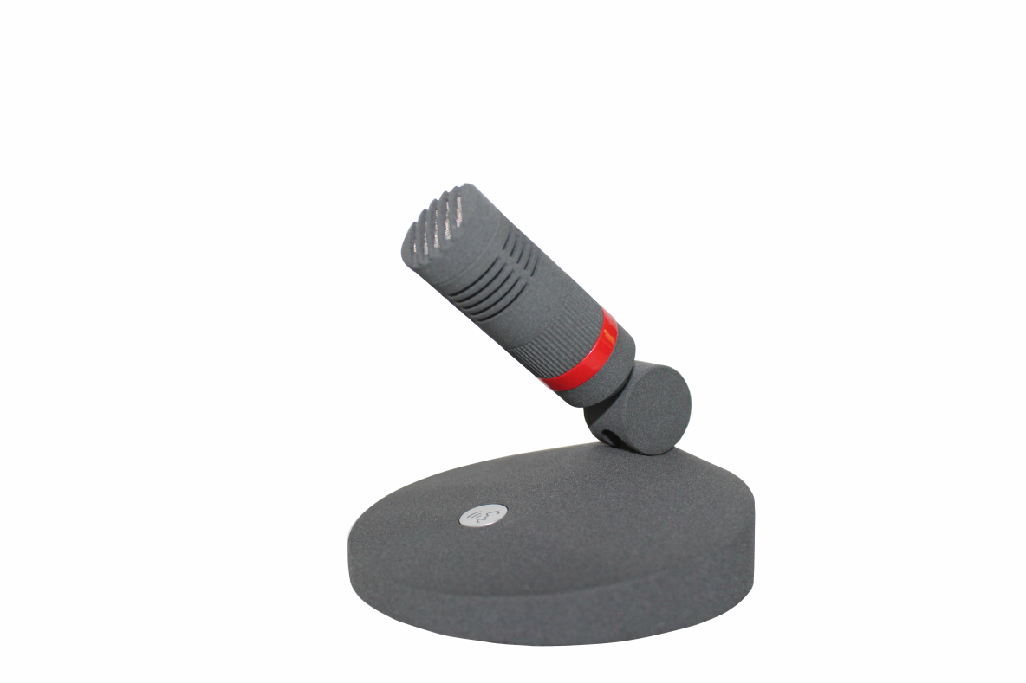

### **Overview**

1. Hypercardioid directional microphone head.

2. The mid frequency is flat, with a slight increase in high frequency, resulting in clear and authentic speech.

3. Metal material velvet seat, compact, beautiful and durable.

4. 48V phantom power supply.

5. Specially tuned microphone circuits and professionally tuned microphone cores enable long-distance pickup.

### **Specifications**

|  |  |
| --- | --- |
| **Parameter** | **Value** |
| Transducer Type | Electret condenser |
| Polar pattern | Hypercardioid |
| Frequency Response | 20Hz - 20kHz |
| Sensitivity | -34dB(20mV/Pa) |
| Equivalent noise level | ≤25dBA |
| Max. sound pressure level | 138dB |
| Power supply | 48V |
| Connection line length | 5m/ (Outlay) |
| Output interface | 3-pin male XLR |
| Mic head diameter | 20mm |
| Mic head length | 40mm |
| Overall height | 48mm |
| Circular base diameter | 84.5mm |
| Microphone sponge cover length | 70mm |
| Microphone sponge cover width | 46mm |
| Weight of microphone without sponge cover | 0.38kg |
| Weight of microphone with sponge cover | 0.385kg |
| Sponge cover weight | 0.005kg |
| Microphone + packaging box + wire + accessory weight | 0.82kg |

### **Frequency Response Curve**

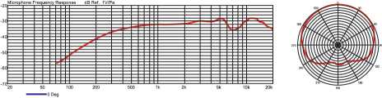

### **Connector**

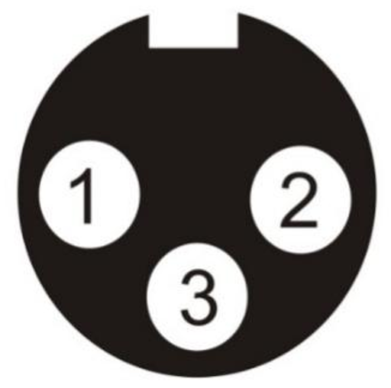

1.Ground(sleeve);

2.Positive(hot);

3.Negative(cold).

XLR-3 Connector

### **Standard configuration**

1 microphone

1 professional windproof sponge cover

1 shockproof packaging paper box

1 product qualification certificate

1 5-meter mini Cannon line