GEAZAN Interactive Digital Audio Processor
(Model No.: MC180V2-E)

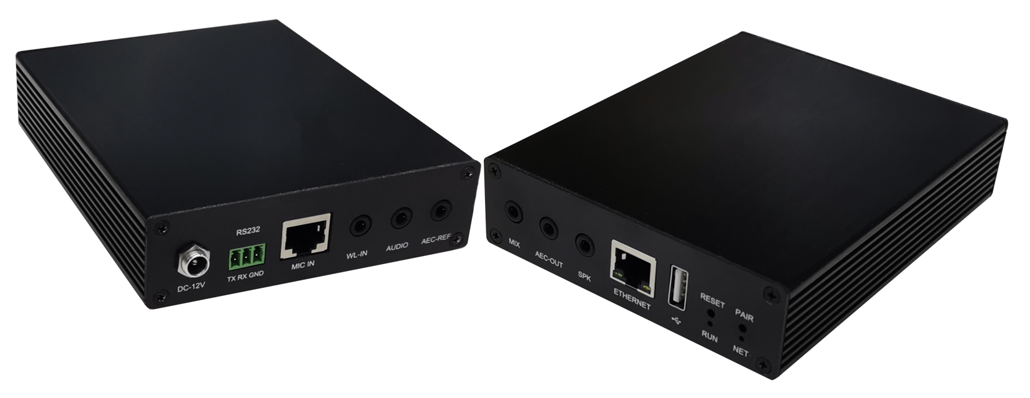

Overview
MC180V2-E is a pendant professional digital audio processor use for far field sound pickup, designed by GEAZAN. It supports 2 balanced microphone cascade inputs by an additional RJ-45 connector for daisy-chain connections,1 external wireless microphone input, 2 stereo inputs, 3 stereo outputs, and 1 USB interface, 1 RJ-45 ethernet port for control communication. It has acoustic echo cancellation, adaptive noise suppression, adaptive reverberation suppression and intelligent mixing functions.
MC180V2-E is equipped with GEAZAN's exquisite and compact spherical omnidirectional microphone and wireless microphone to achieve excellent remote interactive effects and local recording effects. It meets the needs of high-quality audio for distance education and conferences, and has a very high signal-to-noise ratio. The sound quality is clear and natural.

Highlights
  - With USB audio interface, it can be integrated into large screen or PC as sound card to import and export professional audio.
  - RJ45 standard Ethernet port, 3.5mm standard audio port and USB 2.0 port are adopted to solve the problem of cable production.
  - Professional audio, a new generation of echo cancellation and noise suppression algorithm with excellent performance, clear speech quality, smooth interaction and no echo.
  - Visual control software.
  - Suitable for normalized recording and playback classrooms and interactive teaching.

Features
- 1 microphone input network interface, which can access two wired microphones.
- 1 external wireless microphone input, using 3.5mm headphone interface.
- 2 stereo line input, using 3.5mm headphone interface.
- 3 stereo line outputs, using 3.5mm headphone interface.
- 1 USB 2.0 type A interface, supports bidirectional audio data transmission.
- 1 RS232 serial port, which can be connected to the control terminal.
- 1 RJ45 interface, which can be connected to the configuration computer.
- 1 RESET key to restore the default factory settings.

Connection and Usage
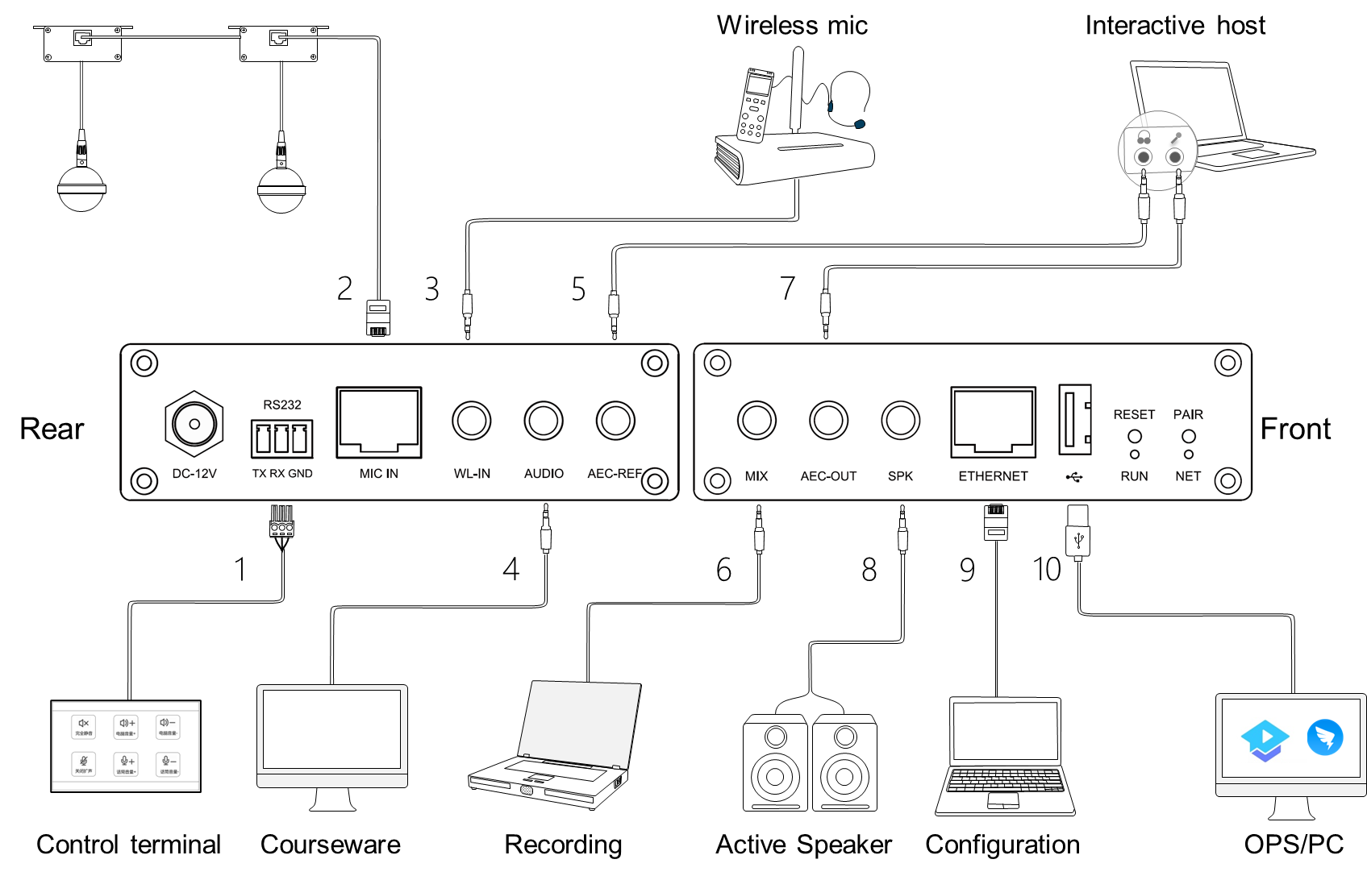
Devices will be connected through the interfaces in the front and rear panel, details are below:
1. RS232: Serial control interface. It can be connected to the external control terminal.
2. MIC IN: Microphone input network interface. It supports 48V phantom power supply and can connect two microphones in cascade through network cable.
3. WL-IN: 3.5mm wireless microphone input interface. It can be connected to a wireless microphone.
4. AUDIO: 3.5mm line input interface. It can be connected to local sound source input, such as DVD, computer, etc.
5. AEC-REF: 3.5mm line input interface. It can access the signal from the remote end in interactive and distance teaching, that is, reference signal input.
6. MIX: 3.5mm line output interface. It can be connected to external recording equipment.
7. AEC-OUT: 3.5mm line output interface. The processed audio signal is output to the far end.
8. SPK: 3.5mm line output interface. It can be connected to an external power amplifier or an active speaker.
9. ETHERNET: RJ45 interface. It can be connected to the configuration computer.
10. USB2.0 type A interface: It supports bidirectional audio data transmission.

Accessories List

No. | Model | Image | QTY | Description
1 | MC180V2-E | 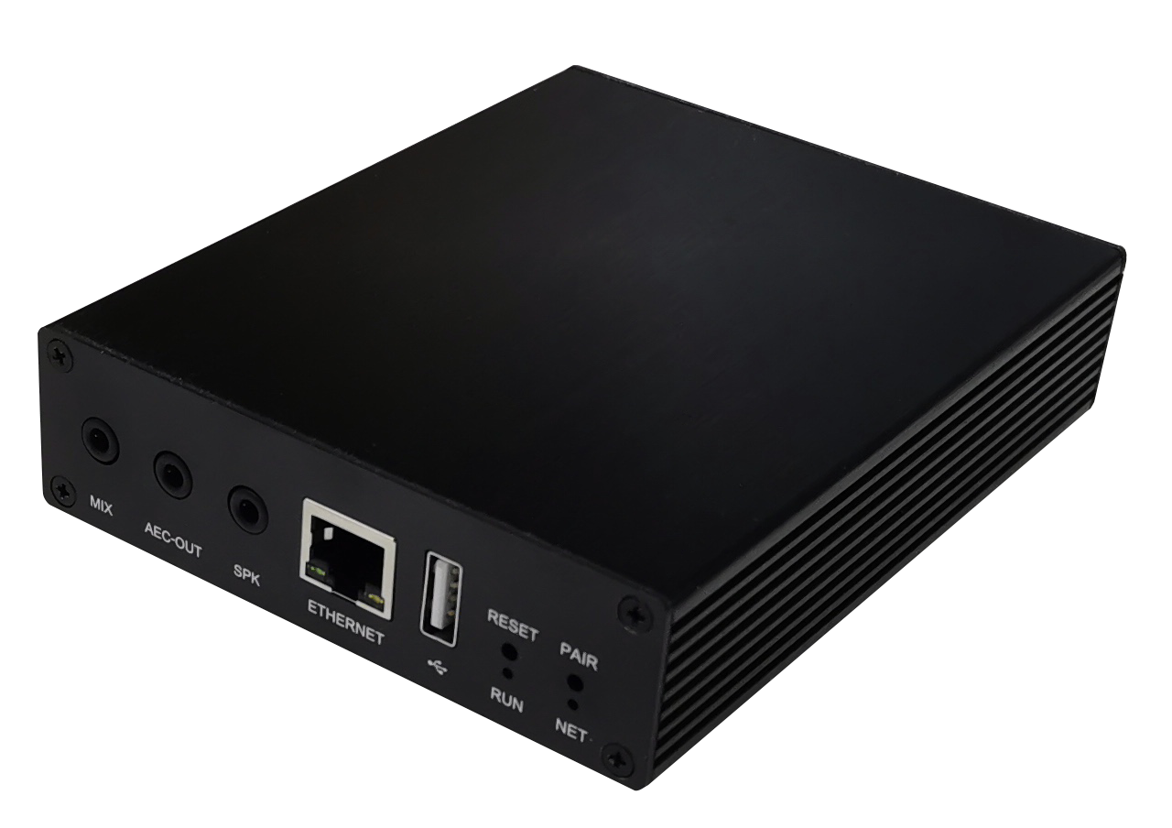 | 1 | Digital audio processor.
2 | ML100-M | 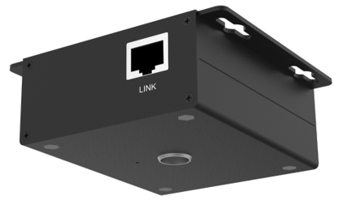 | 1 | Master microphone connection box.
3 | FM280 | 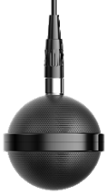 | 1 | Spherical omnidirectional microphone.
4 | ML100-S | 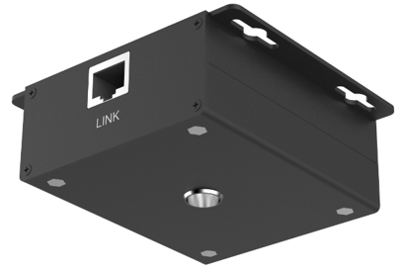 | 1 | Slave microphone connection box, optional.
5 | FM280 |  | 1 | Slave microphone, optional.

Specifications
- Audio Processor MC180V2-E:
Parameter | Value
Frequency Response (20Hz~16kHz @ +4dBu):
Microphone Channel | +0/-2dB
Line Input Channel | +0/-0.5dB
THD +N (1kHz @ +4dBu):
Microphone Channel | < 0.009%
Line Input Channel | < 0.007%
Equivalent Noise | < -84dBu(20Hz~16kHz@22dB)
Dynamic Range | > 105dB(20Hz~16kHz@0dB)
Maximum Input Balance
Microphone Channel | -2dBu
Line Input Channel | 20dBu
Maximum Output Balance | 20dBu
Maximum Gain
Microphone Channel | 50dB
Line Input Channel | 0dB
Input Impedance
Microphone Channel | 2.2KΩ
Line Input Channel | 20KΩ
Output Impedance | 400Ω
Sampling Frequency | 32kHz
A/D-D/A Converter | 24-bit
Phantom Power | DC 48V
Size | 109mm×136mm×30mm

- Spherical Microphone FM280:
Parameter | Value
Transducer Type | Φ24 back electret condenser
Circuit Characteristics | JFET impedance transformation; electronic balance
Directionality | Omnidirectional
Frequency Response | 50Hz-20kHz
Sensitivity | -44±3dB (0dB=1V/Pa@1kHz)
Rated Output Impedance | 2.2kΩ
Minimum Load Impedance | 1kΩ
SNR | 75dB(S:(f=1kHz@1Pa) N:(A-Weighted curve))
Maximum Sound Pressure Level | 115dB(f=1kHz，THD＜1%)
Power Supply | Support 48V phantom power supply
Dynamic Range | 104dB（20Hz-20kHz@2.5kΩ）
Maximum Output Electrical Level | -50dBu（20Hz-20kHz, THD<1%@2.5kΩ）
Working and Storage Temperature | 0-45℃/-20-70℃ (32 - 113 °F/-4 to 158 °F)
Working and Storage Humidity | 10% - 90% (non-condensing)
Output Connection and Cable | Mini XLR-3 Male/ Twisted Shielded MIC Cable
Color | Matte black
Net Weight | 43g
Dimensions | Φ53×54mm

