

**MC180V2-E HANDBOOK**

|  |  |
| --- | --- |
|  |  |
|  |  |

© 2022 Shenzhen Geazan Technology Co., Ltd. All rights reserved.

Contents

1 Introduction 2

1.1 What does this handbook do? 2

1.2 Overview of the audio processor 2

2 Connection and Usage 3

3 Panel operation 4

4 Software 5

4.1 Connection of PC Client-end and Processor 5

4.2 Acoustic Echo Cancellation configuration 6

4.3 NLP(Nonlinear Processing) Setting 8

4.4 Noise Reduction Setting 8

4.5 AGC(Automatic Gain Control) Setting 9

4.6 Dereverberation Setting 10

4.7 High-Pass Filter Setting 10

4.8 Low-Pass Filter Setting 11

4.9 Parameter Equalizer Setting 11

4.10 Leveler Setting 12

4.11 Auto Mixer Setting 12

4.12 Level Control Setting 12

4.13 Meter Display 12

4.14 Ducker Setting 13

4.15 atrix Mixer Setting 13

4.16 Other Settings 14

4.17 Save the Scenario Configuration File 15

4.18 Read Scenario Configuration File 16

5 FAQ 18

5.1 Output without Voice 18

5.2 Current Noise in Output Voice 18

5.3 Remote Interactive Echo cannot Cancel? 18

# Introduction

## What does this handbook do?

The handbook will help users how to fix and use the MC180V2-E audio processor, the readers will be engineers who participate in site operation and test.

## Overview of the audio processor

The interactive type MC180V2-E is a compact digital audio processor designed for both local classroom recording and distance education by GEAZAN, with 2-channel balanced microphone cascade inputs, 1 external wireless microphone input, 2-channel stereo line inputs, 3-channel stereo line outputs and 1 USB interface. Audio processor MC180V2-E uses core audio algorithms including adaptive noise reduction, smart mixing, and voice tracking etc., additionally supports various audio signal processing modules and signal routing allocation, which could be designed through PC software by users.

# Connection and Usage

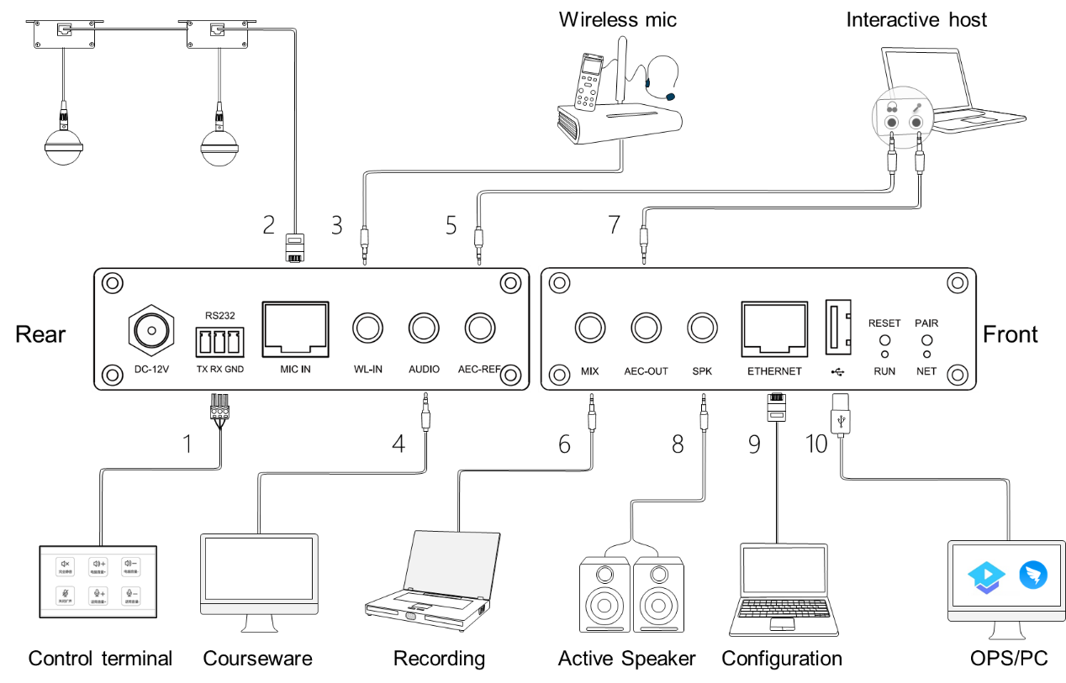

Devices will be connected through the interfaces in the front and rear panel, details are below:

1. RS232: Serial control interface. It can be connected to the external control terminal.

2. MIC IN: Microphone input network interface. It supports 48V phantom power supply and can connect two microphones in cascade through network cable.

3. WL-IN: 3.5mm wireless microphone input interface. It can be connected to a wireless microphone.

4. AUDIO: 3.5mm line input interface. It can be connected to local sound source input, such as DVD, computer, etc.

5. AEC-REF: 3.5mm line input interface. It can access the signal from the remote end in interactive and distance teaching, that is, reference signal input.

6. MIX: 3.5mm line output interface. It can be connected to external recording equipment.

7. AEC-OUT: 3.5mm line output interface. The processed audio signal is output to the far end.

8. SPK: 3.5mm line output interface. It can be connected to an external power amplifier or an active speaker.

9. ETHERNET: RJ45 interface. It can be connected to the configuration computer.

10. USB2.0 A connector: It supports bidirectional audio data transmission.

# Panel operation

The front panel of the audio processor can perform operations such as connecting the configuration computer, factory setting recovery and operation state observation.

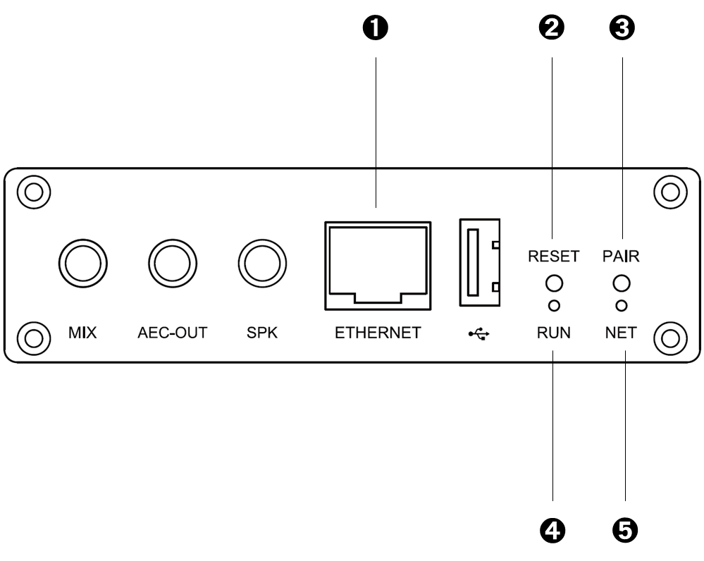

1. ETHERNET, it can be connected to the configuration computer.

2. RESET, restore the factory configuration key. Long press 3s to restart the device and restore the factory configuration.

3. PAIR, reserved function key.

4. RUN indicator, operation status indication, slow flashing indicates normal operation.

5. NETWORK indicator, network connection status indicator, always on when the network is connected to the PC control terminal.

After the equipment is powered on, the RUN light flashes slowly.

# Software

## Connection of PC Client-end and Processor

In the debugging and testing, the parameters of Audio Processor may be reconfigured through PC in an Ethernet cable, the steps are below:

1. Use the Ethernet cable to connect PC and audio processor;

2. Set IP address of PC: 192.168.1.xxx, subnet mask: 255.255.255.0;

Below for reference:

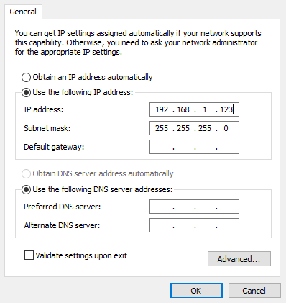

3. Run configuration software, after it starts, click the “Device” icon on the upper right, and see the red circle in the picture below:



4. Click the “Device” icon, popup dialog box below, the default IP address of processor: 192.168.1.100

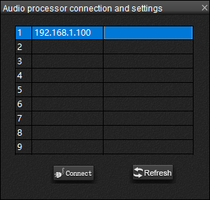

5. Double-click the line of IP address, the connection of computer and processor is finished.

## Acoustic Echo Cancellation configuration

AEC algorithm runs by default, if the parameters of AEC need be reconfigured, the engineer can enter the configuration software to setup, the steps below:

1. Click the icon of control panel on the upper right, see the red circle below:



2. Finish step 1, enter the design panel, see the below:

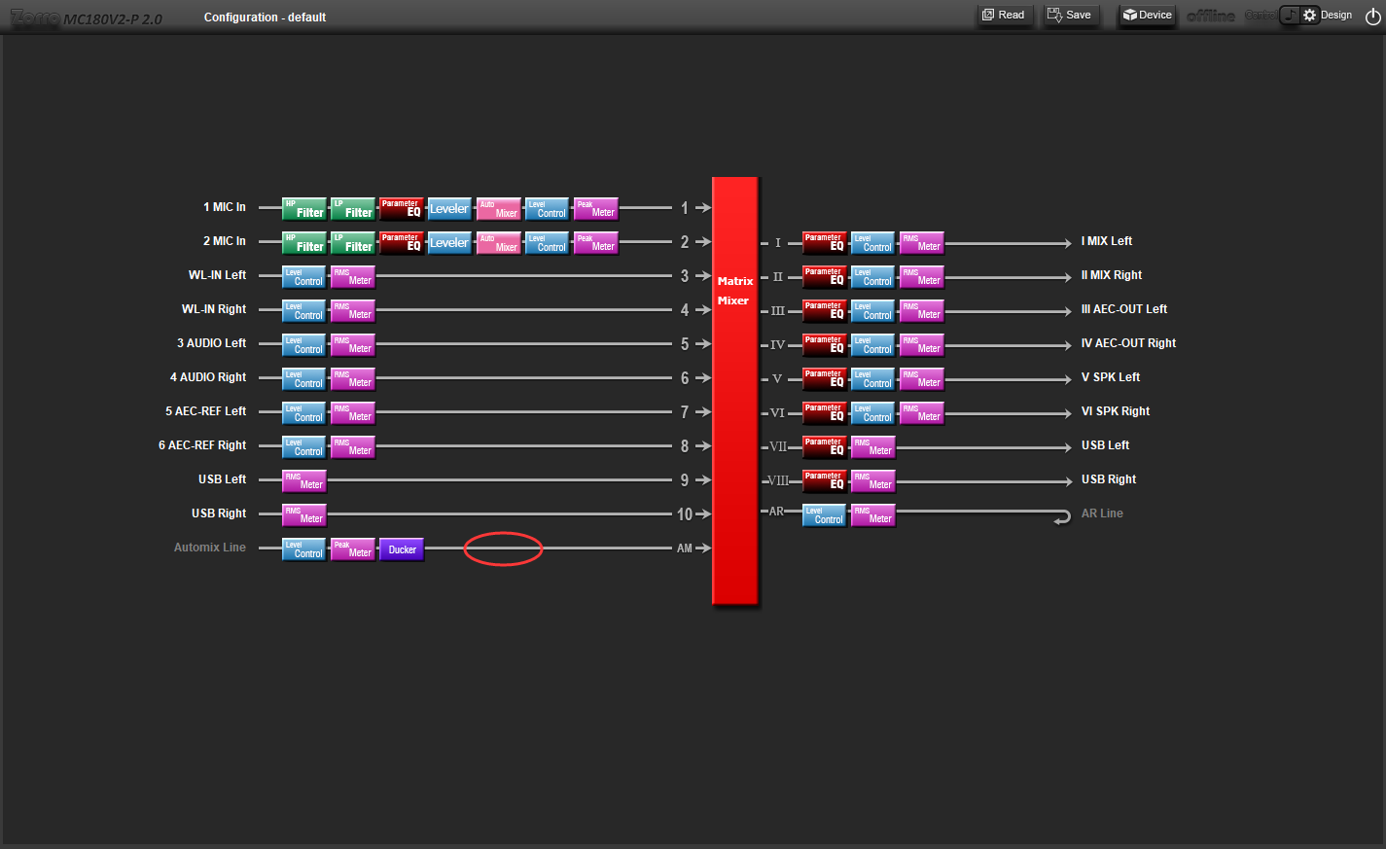

3. Double-click the route of automatic mixing output channel, see the red circle of picture above, will enter sub-panel below:

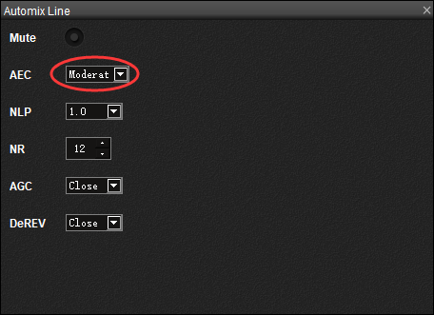

4. In the AEC parameters configuration above, there are four parameters: close, mild, moderate, severe, for choice. ***Close****,* close the algorithm; ***Mild***, provide the best double-end talk effectiveness; ***Severe***, provide the best single-end talk effectiveness; ***Moderate***, provide the balance between single-end and double-end talk effectiveness, for recommendation.

## NLP(Nonlinear Processing) Setting

1. Same as 4.2 , refer to the following figure:

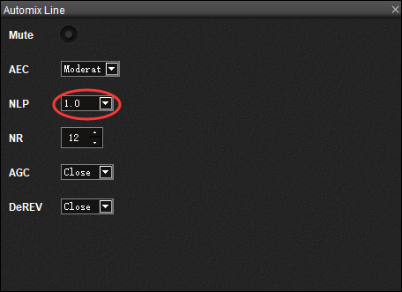

2. In the NLP parameter setting, there are 20 parameters from 0.2 to 2.0 to select, which respectively represent the different degree of AEC nonlinear processing. The larger the value, the cleaner the echo processing, but it will have an impact on the double talk. 1.0 is selected by default.

## Noise Reduction Setting

1. Same as 4.2 , refer to the following figure:

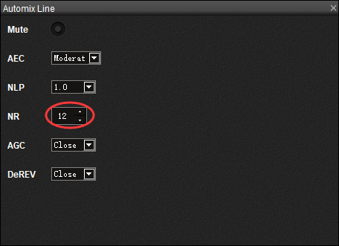

2. The parameters of Noise Reduction, NR, are 0, 6~18, total 14 choices, 0, represents NR algorithm closed; 6, represents NR ratio 6dB; 18, represents NR ratio 18dB; 12dB for recommendation, see the red circle above.

## AGC(Automatic Gain Control) Setting

1.Same as 4.2 , refer to the following figure:

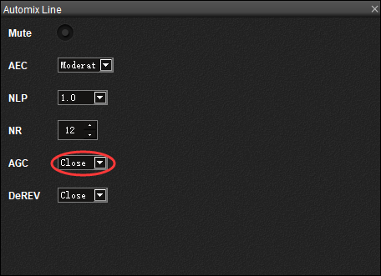

2.In the automatic gain parameter setting, there are two parameters to choose from: "close" and "open", which respectively represent the off and on of the automatic gain algorithm.

## Dereverberation Setting

1.Same as 4.2 , refer to the following figure:

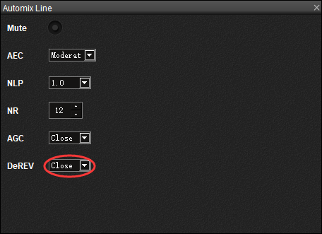

2. In the de reverberation parameter setting, there are two parameters to choose from: "close" and "open", which respectively represent the off and on of the dereverberation algorithm.

## High-Pass Filter Setting

1. Double-click the green icon of High-Pass Filter;

2. Finish the step 1, enter the next sub-panel below:

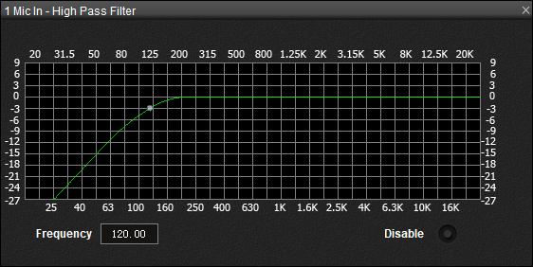

3. Users can choose cut-off frequency of High-Pass Filter, 120Hz for recommendation.

## Low-Pass Filter Setting

1. Double-click the green icon of Low-Pass Filter;

2. Finish the step 1, enter the next sub-panel below:

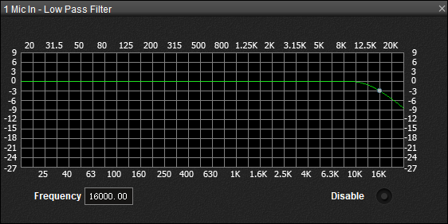

3. Users can choose cut-off frequency of Low-Pass Filter, 16000Hz for recommendation.

## Parameter Equalizer Setting

1. Double-click the icon of Graphic Equalizer;

2. Finish the step 1, enter the next sub-panel below:

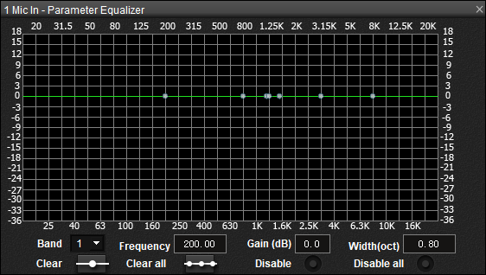

3. Users can choose gain of each frequency band.

## Leveler Setting

Leveler is a compressor, of which the compress ratio is 10:1. Leveler is open by default, usually it is not suggested to change these settings.

## Auto Mixer Setting

The Auto Mixer turns 8-channel Mic Inputs to auto-mixing outputs. This module is strongly suggested to use default parameters, instead of changing settings.

## Level Control Setting

Level control module exists system input-end and output-end, adjusting the volume of system input and output, Setting is below:

1. Double-click Level Control icon;

2. The display is below, users can use the slider to vary level, setting ranges, [-100dB，12dB];

! Attention: Varying the volume of Microphone input will not change the volume of the Auto-Mixer Line input.



## Meter Display

There are 2 volume displays of input and output level, Peak value and Root-Mean-Square value, RMS. Usually Mic Input uses Peak value meter, Line Input/Output uses RMS value meter.

Usually, it is reasonable that the value of output volume is in the yellow area, see the picture below:



## Ducker Setting

1. Double-click the ducker icon.

2.After the previous step is completed, the following interface will be displayed:

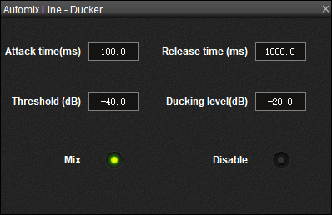

3.Enable this module function when wireless microphone input is required to mask wired microphone input.

## atrix Mixer Setting

In the configuration software, the input interface is named by Arabic numbers: 1, 2, 3, 4, …, the output interface is named by Roman numbers: I, II, III, IV,…

Besides, there are two special interfaces in the device, AM, and AR:

* AM is an input interface of the Auto Mixer, all microphone signals after auto mixing are outputting from this one;
* AR is a reference output interface of Echo Cancellation, receiving the signal for echo cancellation reference.

Usually we use default configuration below:

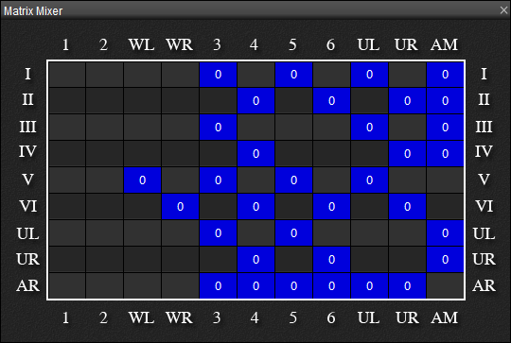

The detailed descriptions below:

* Output I and II: mix output, access the recording equipment for recording. The inputs select AM (local microphone automatic mixing input, contains wireless microphone input), local line input, remote input, and USB input.
* Outputs III and IV: AEC-OUT remote output. The inputs select AM, local line input, and USB input.
* Output V and VI: speaker output, generally connected to the external power amplifier. The inputs select WL-IN (wireless input), local line input, remote input, and USB input.
* Output UL and UR: The inputs select AM, local line input, and remote input.
* Output AR: The inputs select Input local line input, remote input, and USB input, as reference signals.

## Other Settings

Enter the design interface and double-click the line of the input or output channel to set some or all parameters such as mute, line name and gain.

For example, double clicking MIC input channel 1 will enter the following sub interface, which supports setting whether to mute, modifying channel name and modifying input gain value.

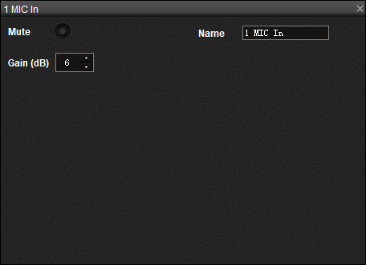

## Save the Scenario Configuration File

Configuration of the client-end and processor keep synchronization when the processor is connected to configuration software client-end. Break the connection, the processor will save the current configuration automatically. If dump and restart, the processor runs in this configuration that is very convenient for debugging and testing.

During the installation, user finishes the debugging of the audio processor, can save configuration file. When this processor works at the same scenario, it can read the configuration file directly, instead of re-debugging every time. The steps are below:

1. Click the icon of control panel, see the red circle below:



2. Save as xxx.adc configuration file, xxx, users name it, this handbook names it default.adc, see the picture below:

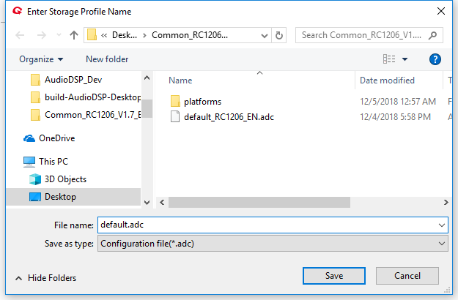

## Read Scenario Configuration File

Installing the audio processor at the same scenario, it can read the configured parameters, speeding up the installation and debugging, the steps are below:

1. Click the read icon on the control panel, see the picture below:



2. Read the xxx.adc configuration file saved before, see the picture below:

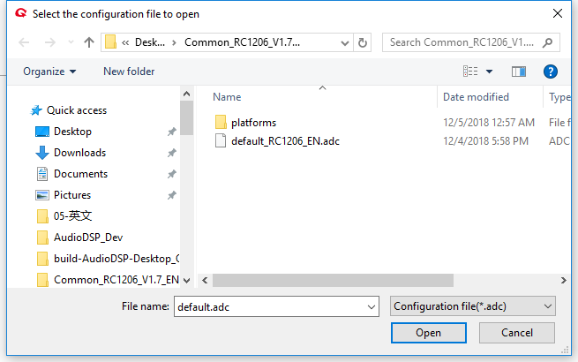

3. The audio processor read the configuration file, the panel will display the picture below, waiting for around 10 seconds, and it will complete the parameters configuration.

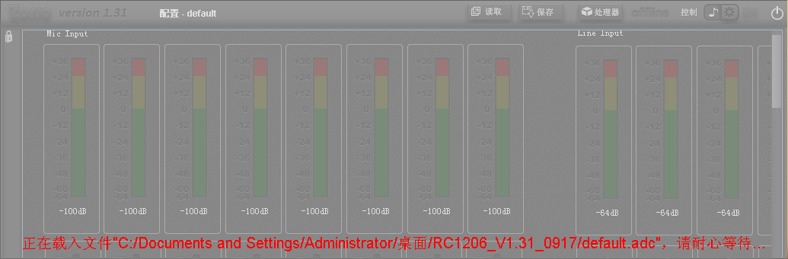

# FAQ

## Output without Voice

1. Check the POWER indicator of processor on or not.

2. Check the RUN indicator slow flashing or not.

3. Check the input/output interface connection right or not.

4. Check the signal of Mic Input source and Line Input source normal or not.

5. Check Matrix configuration right or not.

6. Start software to check the meter running or not.

## Current Noise in Output Voice

1. Does audio patch cord make right?

2. Does the audio wire need the shield wire to connect?

3. Does the input signal level oversize?

## Remote Interactive Echo cannot Cancel?

1. Check the remote-end reference signal access right or not.

2. Check the AEC algorithm open or not.

3. Do Amplifier and speaker access connect to the audio processor?

4. Check the remote-end reference signal level right or not, does the signal arrive at the yellow area?

5. Is the remote-end input audio source the same at the local voice in the speaker (Does the speaker crack or distort)?