**GEAZAN 12-Channel Interactive**

**Digital Audio Processor**

**(Model No.: RC1206V2-U)**

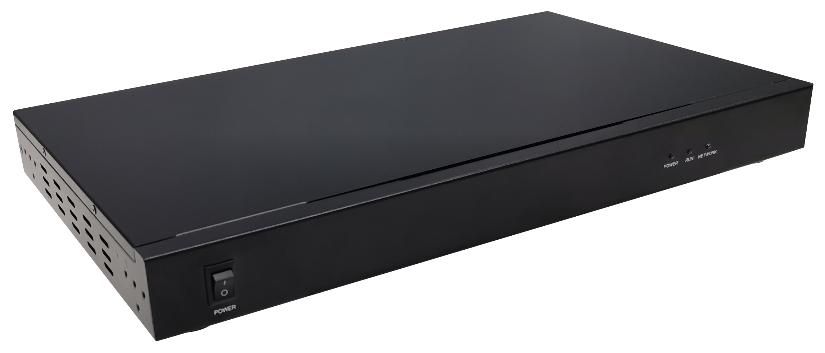

Overview

RC1206V2-U is a 12-channel interactive digital audio processor designed by GEAZAN. It adopts adaptive echo cancellation, adaptive dereverberation, adaptive noise reduction, and smart mixing technology and has an extremely high SNR reproducing a clear and natural sound.

According to the design ideas of GEAZAN’s smart, configuration-free and simple to use, RC1206V2-U adopts adaptive algorithm and is ready to use after installation. It is convenient for engineers to install and debug, and also meets the needs of normalized interaction and audio collection of recording system.

Features

* 8 Balanced mic inputs, support 48V phantom power supply, phoenix connector.
* 4 Balanced line inputs, phoenix connector.
* 6 Balanced line outputs, phoenix connector.
* 1 Wireless microphone interface, 3.5mm connector.
* 1 Monitor headphone interface, 3.5mm connector.
* 1 USB2.0 type A interface, supports bidirectional audio data transmission.
* 1 RS232 serial port, which can be connected to the control terminal.
* 1 RJ45 interface, which can be connected to the configuration computer.
* 1 RESET key to restore the default factory settings.

Connection and Usage

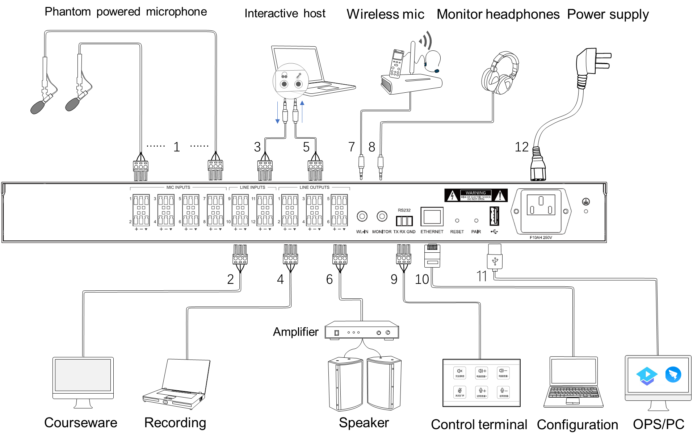

Devices will be connected through the interfaces in the rear panel, details are below:

1. MIC INPUTS (1-8): 8 balanced microphone input interfaces, supporting 48V phantom power supply, suitable for accessing omni-directional and directional microphone.

2. LINE INPUTS (9-10): Line input interfaces. It can be connected to local sound source input, such as DVD, computer, etc.

3. LINE INPUTS (11-12): Line input interfaces. It can access the signal from the remote end in interactive and distance teaching, that is, reference signal input.

4. Line Outputs (1-2): Line output interfaces. It can be connected to external recording equipment.

5. Line Outputs (3-4): Line output interfaces. The processed audio signal is output to the far end.

6. Line Outputs (5-6): Line output interfaces. It can be connected to an external power amplifier or an active speaker.

7. WL-IN: 3.5mm wireless microphone input interface. It can be connected to a wireless microphone.

8. MONITOR: 3.5mm monitor headphone interface. It can be connected to a monitor headphone.

9. RS232: Serial control interface. It can be connected to the external control terminal.

10. ETHERNET: RJ45 interface. It can be connected to the configuration computer.

11. USB2.0 type A interface: It supports bidirectional audio data transmission.

12. Power supply.

Appearance and Interfaces

**Front**



**Instructions for Front Panel**

|  |  |
| --- | --- |
| **Interface, Indicator and Knobs** | **Function Description** |
| POWER key | Power switch |
| POWER indicator | The power indicator remains on after power on. |
| RUN indicator | The operation indicator flashes slowly, indicating normal operation. |
| NETWORK indicator | Network connection indicator, always on when network and PC control terminal connection is established |

**Rear**



**Instructions for Rear Panel**

|  |  |
| --- | --- |
| **Interface, Indicator and Knobs** | **Function Description** |
| Mic Inputs(1-8) | 8 balanced microphone input interfaces, supporting 48V phantom power supply. |
| Line Inputs(9-10) | 2 (left and right channel) line input interfaces, for the local audio source, such as DVD, computer, etc. |
| Line Inputs(11-12) | 2 (left and right channel) line input interfaces to access the signal from the remote end in interactive and distance teaching. |
| Line Outputs(1-2) | 2 (left and right channel) line output interfaces, external recording equipment can be connected. |
| Line Outputs(3-4) | 2 (left and right channel) line output interfaces to output the processed audio signal to the far end. |
| Line Outputs(5-6) | 2 (left and right channel) line output interfaces, which can be connected to power amplifier or active speaker for local sound reinforcement output. |
| WL-IN | 3.5mm wireless microphone input interface. |
| MONITOR | 3.5mm monitor headphone interface. |
| RS232 | The serial control interface, can be connected to the control terminal. |
| Ethernet | RJ45 interface to PC for configuration. |
| RESET | Restore the factory configuration key. Long press 3s to restart the device and restore the factory configuration. |
| PAIR | Reserved function keys. |
| USB2.0 type A interface | Support bidirectional audio data transmission. |
| Power interface | 100-240V AC 50/60Hz |

Specifications

| **Parameter** | **Value** |
| --- | --- |
| Frequency Response (20Hz~16kHz @ +4dBu): |  |
| Microphone Channel | +0/-2dB |
| Line Input Channel | +0/-0.5dB |
| THD +N (1kHz @ +4dBu): |  |
| Microphone Channel | < 0.009% |
| Line Input Channel | < 0.007% |
| Equivalent Noise | < -84dBu(20Hz~16kHz@22dB) |
| Dynamic Range | > 105dB(20Hz~16kHz@0dB) |
| Maximum Input Balance |  |
| Microphone Channel | -2dBu |
| Line Input Channel | 20dBu |
| Maximum Output Balance | 20dBu |
| Maximum Gain |  |
| Microphone Channel | 50dB |
| Line Input Channel | 0dB |
| Input Impedance |  |
| Microphone Channel | 2.2KΩ |
| Line Input Channel | 20KΩ |
| Output Impedance | 400Ω |
| Sampling Frequency | 32kHz |
| A/D-D/A Converter | 24-bit |
| Phantom Power | DC 48V |
| Size | 440mm×255mm×44mm |